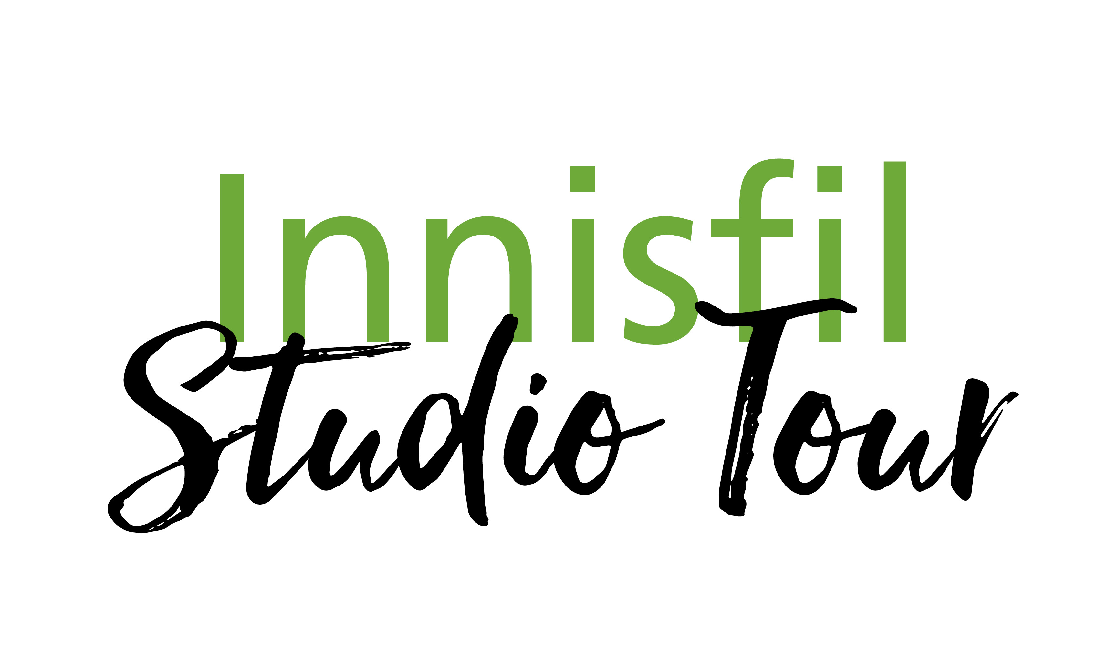

Annual Innisfil Autumn Art Show & Sale

November 2 & 3, 2024

**CALL FOR ARTISTS**

**Applications are available on the website** [www.innisfilstudiotour.ca](http://www.innisfilstudiotour.ca)

**Application Deadline: August 23, 2024**

The Innisfil Autumn Art Show & Sale is an opportunity for artists who are residents of Innisfil, along with guest artists, to connect with art lovers locally as well as from afar. The Show gives artists the opportunity to showcase and sell their art, view demonstrations and share their creative process.

The Autumn Art Show & Sale is managed by a volunteer committee and supported by Simcoe County Tourism. Our goal is to feature exciting and diverse artwork that highlights the talents of local experienced artists as well as new emerging artists. Artwork will be juried by the committee, based on quality, consistency and professionalism.

We cannot guarantee that all applications will be accepted.

## Benefits of Participation:

* Promotion of your work and exhibition location on the tour brochure and website
* Exposure through the Tour’s website and social media sites, local newspapers, magazines, local radio coverage, and marketing through Simcoe County Tourism
* Supply of brochures for distribution.
* Brochures distributed to local business, retailers, and Tourism Kiosks throughout the region
* An opportunity to showcase your art in Innisfil, to both local and wider audiences
* Meeting, networking and receiving support from other artists
* Media night approximately three weeks prior to the Tour

**Studio Tour dates:**

Saturday, Nov. 2, 2023, 10am – 5pm

Sunday, Nov. 3, 2023, 10am – 3pm

For additional information visit www.innisfilstudiotour.ca or contact:

Innisfil Studio Tour c/o Sydney Hardie

[sydney@hardieandcompany.com](mailto:info@iachc.ca)

705-984-5120 voice and text

[www.iachc.ca](http://www.iachc.ca) | [www.innisfilstudiotour.ca](http://www.innisfilstudiotour.ca)