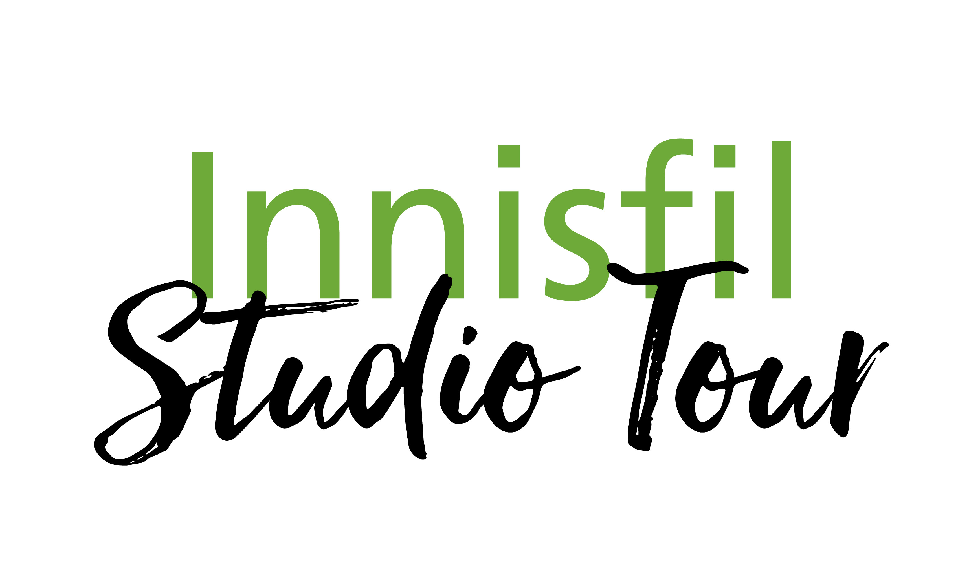

**2024 Application**

**Autumn Art Show & Sale**

**Location: Innisfil ideaLAB & Library**

**967 Innisfil Beach Rd, Innisfil, ON L9S 1V3**

**Saturday, Nov. 2, 2024, 10am – 5pm**

**Sunday, Nov. 3, 2024, 10am – 3pm**

Artist Name:

Email:

Studio Name:

Website:

Phone:

Please describe your work, including details about materials and techniques:

Number of tables and/grids required to display work:

All works must be original and NOT be  
made from a kit or a commercial mold.

No sale of consumable goods are permitted.   
Only artists who have paid an application fee may exhibit and sell work

Terms and Conditions

**Entry fee**

* $125 per artist

You can pay online with **PayPal** at [www.innisfilstudiotour.ca/apply.php](http://www.innisfilstudiotour.ca/apply.php),  
or provide a *post-dated cheque for September 15*, payable to the *Innisfil Arts, Culture and Heritage Council*.

Applications may be submitted by mail or digitally by email. Along with your application please submit at least 3-5 digital samples of your art to [Sydney@hardieandcompany.com](mailto:Sydney@hardieandcompany.com). Images will be used for promotional purposed on the website and brochure.

**Applications Due: August 23, 2024**

**Artists will be notified of acceptance by August 30, 2024.**

There will be no refunds after September 15, 2024. Refunds prior to this date will be subject to a $25 administrative fee.

Each artist shall pick up and distribute brochures and should promote the Art Show as much as possible.

A digital file of 3 .jpg art samples must be submitted for the brochure.

Signature of artist:

Date:

☐ Payment enclosed

☐ Paid online via Paypal

**MAIL your completed application** to:

Innisfil Studio Tour, c/o Sydney Hardie

654 Lakelands Ave.

Alcona, Innisfil   
L9S 4E6

**or EMAIL application to:**

[Sydney@hardieandcompany.com](mailto:Sydney@hardieandcompany.com)

[www.iachc.ca](http://www.iachc.ca) | [www.innisfilstudiotour.ca](http://www.innisfilstudiotour.ca)